

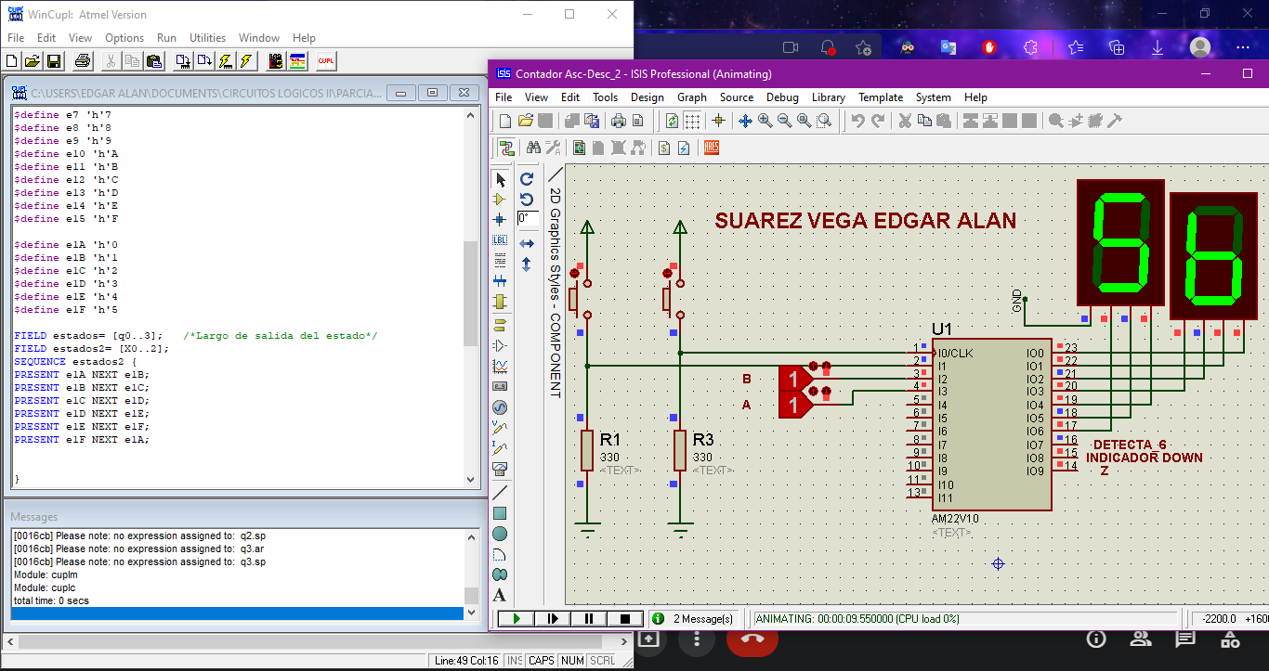

|  |  |  |  |  |
| --- | --- | --- | --- | --- |
| Instrucción | Almacenar | Habilitar | Entrada |  |
|  | Registro | Salida | Salida Ext |  |
|  | Pulso |  |  |  |
|  | RX1RX0 | RS1RS0 | CE*/DIR | PULSO |
| MOV RX0, 0X02 | 00 | 00 | 0/00/0 | H |
| MOV RX2,0X05 | 10 | 000 | 0/0 | H |
| MOV RX3, 0X00 | 11 | 000 | 0/0 | H |
| MOV RX1, RX2 | 01 | 110 | 1/X | H |
| MOV RX3, RX0 | 11 | 100 | 1/X | H |

